

**Project Name : - Relational Databases**

**Product Dissection for WhatsApp**

### **Company Overview:**

WhatsApp was founded in February 2009 by [Brian Acton](https://en.wikipedia.org/wiki/Brian_Acton) and [Jan Koum](https://en.wikipedia.org/wiki/Jan_Koum), former employees of [Yahoo!](https://en.wikipedia.org/wiki/Yahoo!).It allows users to send [text](https://en.wikipedia.org/wiki/Text_message), [voice messages](https://en.wikipedia.org/wiki/Voice_message) and video messages, make voice and video calls, and share images, documents, user locations, and other content.

The service was created by WhatsApp Inc. of [Mountain View, California](https://en.wikipedia.org/wiki/Mountain_View,_California), which was acquired by Facebook in February 2014 for approximately [US$](https://en.wikipedia.org/wiki/United_States_dollar)19.3 billion.It became the world's most popular messaging application by 2015, and had more than 2 billion users worldwide by February 2020.

### **Product Dissection and Real-World Problems Solved by WhatsApp :**

Product dissection involves taking apart a product to understand how it works, its components, and how they contribute to its overall functionality. WhatsApp is a messaging application that primarily serves as a platform for text and multimedia messaging, voice and video calls, and group communication. While it may not be as complex as physical products, we can still analyze it and discuss real-world problems it solves:

**1. Instant Communication:** WhatsApp enables people to communicate in real-time, which is essential for emergencies, urgent business matters, or staying in touch with loved ones who are far away. It has revolutionized the way people connect globally.

**2. Cost-Effective International Communication:** By using Wi-Fi or mobile data, WhatsApp allows users to send text messages, make voice or video calls, and share media across borders without incurring additional international call or text charges. This solves the problem of expensive international communication.

**3. Group Communication:** WhatsApp's group feature facilitates collaboration and coordination among teams, families, friends, or interest-based communities. It's a valuable tool for project management, event planning, and staying in touch with larger social circles.

**4. End-to-End Encryption:** WhatsApp's use of end-to-end encryption helps protect users' privacy and ensures that only the intended recipients can read their messages. It addresses the problem of unauthorized access and surveillance.

**5. Business Communication:** WhatsApp Business allows companies to interact with customers efficiently, providing customer support, sending updates, and processing orders. It solves the problem of streamlining business communication and enhancing customer service.

**6. Audio and Video Calls:** WhatsApp enables high-quality audio and video calls, reducing the need for traditional phone calls. This is particularly useful for remote work, keeping in touch with family, and reducing phone bill expenses.

**7. File Sharing:** Users can send documents, photos, videos, and other files through WhatsApp, making it a versatile tool for sharing information, solving the problem of transferring data between devices and individuals.

**8. Voice Messages:** Voice messages are a useful feature for users who prefer to send spoken messages instead of typing, catering to people with disabilities or those who are multitasking.

**9. Location Sharing:** This feature allows users to share their real-time location with others, which is helpful in emergencies, meet-ups, or when providing directions.

**10. Status Updates:** Users can post short-lived status updates, similar to stories on other platforms, letting their contacts know what they're up to. This feature solves the problem of sharing real-time information or updates with a broad audience.

In conclusion, while WhatsApp isn't a physical product that can be dissected in the traditional sense, it's a digital tool with various features that address real-world communication and connectivity problems, making it an integral part of many people's lives.

### **Case Study: Real-World Problems and WhatsApp Innovative Solutions**

**Problem 1: Slow Communication in Emergency Situations**

**Real-World Challenge:** In emergency situations, timely communication is crucial. Traditional methods, such as phone calls or text messages, may not always be efficient when immediate action is needed.

**WhatsApp’s Solution:**

WhatsApp's real-time messaging and voice call features allow users to communicate instantly, ensuring that they can reach out for help or provide updates rapidly during emergencies. This has been particularly valuable in disaster situations where communication infrastructure may be compromised, and the ability to send messages via Wi-Fi or mobile data can save lives.

**Problem 2: Costly International Communication**

**Real-World Challenge:** International phone calls and text messages can be expensive, limiting global communication for many people, especially those with friends and family abroad or businesses with international connections.

**WhatsApp’s Solution:**

WhatsApp's internet-based messaging and calling services have significantly reduced the cost of international communication. Users can send text messages, make voice and video calls to contacts anywhere in the world over Wi-Fi or mobile data, bypassing traditional international calling fees.

**Problem 3: Privacy and Security Concerns**

**Real-World Challenge:** With the increasing digital presence, there are growing concerns about privacy and security, especially regarding personal and sensitive information shared through communication channels.

**WhatsApp’s Solution:**

WhatsApp introduced end-to-end encryption to address these concerns. This technology ensures that only the intended recipient can read the messages, making it extremely difficult for third parties to intercept or decipher the content. This level of security has made WhatsApp a trusted platform for private conversations and business communications.

**Problem 4: Inefficient Business Communication**

**Real-World Challenge:** Traditional email and phone systems can be inefficient for businesses looking to provide real-time customer support and engage with clients effectively.

**WhatsApp’s Solution:**

WhatsApp Business provides a dedicated platform for businesses to interact with customers efficiently. It allows for automated responses, business profiles, and labels for organized customer interactions. This solution streamlines communication and enhances customer service, improving the efficiency of business-customer relationships.

#### **Conclusion:**

In Conclusion, WhatsApp has addressed several real-world problems by providing innovative solutions that have transformed the way people communicate, conduct business, and handle emergencies. Its features, such as instant messaging, end-to-end encryption, international communication, and business solutions, have had a significant impact on addressing these challenges and enhancing global connectivity.

### **Top Features of WhatsApp:**

WhatsApp is a widely used messaging application with a variety of features that enhance communication, privacy, and user experience. Here are some of the top features of WhatsApp:

**1. Instant Messaging:** WhatsApp allows users to send text messages and multimedia messages instantly to individuals or groups. It supports text, photos, videos, voice messages, and document sharing.

**2. Voice and Video Calls:** Users can make high-quality voice and video calls over Wi-Fi or mobile data, providing a cost-effective alternative to traditional phone calls.

**3. End-to-End Encryption:** WhatsApp uses end-to-end encryption for all messages and calls, ensuring that only the sender and recipient can access the content. This feature enhances privacy and security.

**4. Group Chats:** WhatsApp supports group chats, allowing multiple users to communicate in a single conversation. Group admins can manage participants and set group rules.

**5. Voice Messages:** Users can send voice messages as an alternative to typing, which is especially useful for quick communication or when typing is not convenient.

**6. Status Updates:** Similar to stories on other platforms, WhatsApp users can post status updates that disappear after 24 hours. This feature allows users to share photos, videos, and text updates with their contacts.

**7. File Sharing:** WhatsApp supports the sharing of various file types, including PDFs, documents, spreadsheets, and more. This is useful for work-related communication and sharing important information.

**8. Location Sharing:** Users can share their real-time location with contacts or in group chats, which is helpful for meet-ups, directions, and safety.

**9. Video and Photo Sharing:** WhatsApp allows users to share photos and videos from their device's gallery. It also offers in-app camera functionality for taking and sending pictures and videos.

**10. WhatsApp Web:** Users can access WhatsApp on their computers through the web browser or desktop applications, enabling seamless communication between mobile and desktop devices.

WhatsApp continues to evolve and add new features, enhancing its functionality and usability for users around the world.

### **Schema Description:**

A schema description for WhatsApp typically includes the data structures and relationships that define the organization and storage of information within the messaging application. Below is a simplified schema description for WhatsApp:

**User Schema:**

**- User:**

**- user_id (Primary Key) :** A unique identifier for each WhatsApp user.

**- phone_number :** The ph

one number associated with the user's WhatsApp account.

**- display_name :** The user's chosen display name.

**- status_message :** The user's status message, often displayed in their profile.

**- profile_picture :** A reference or link to the user's profile picture

**Chat Schema:**

**- Chat:**

**- chat_id (Primary Key) :** A unique identifier for each chat.

**- chat_type :** Defines if it's an individual chat or a group chat.

**- participants (Many-to-Many):** A list of users participating in the chat, allowing multiple user

to be part of the same chat.

**- last_message :** A reference to the last message sent in the chat.

**- unread_count :** Keeps track of the number of unread messages in the chat.

**Message Schema:**

**- Message :**

**- message_id (Primary Key) :** A unique identifier for each message.

**- chat_id (Foreign Key):** References the chat to which the message belongs.

**- sender_id (Foreign Key):** References the user who sent the message.

**- content :** The text or multimedia content of the message (text, images, videos, documents,

etc.).

**- timestamp :** The date and time when the message was sent.

**- is_read :** Indicates whether the message has been read by the recipient.

**Attachment Schema :**

**- Attachment :**

**- attachment_id (Primary Key) :** A unique identifier for each attachment.

**- message_id (Foreign Key) :** References the message to which the attachment is

associated,

**- attachment_type :** Specifies the type of attachment (e.g., image, video, document).

**Relationships are:**

**1. User-Chat Relationship :**

**- One-to-Many :** A user can participate in multiple chats (individual and group chats), but

each chat has multiple participants. This is a one-to-many relationship.

**2. Chat-Message Relationship :**

**- One-to-Many :** A chat can have multiple messages, but each message belongs to a specific

chat. This is a one-to-many relationship.

**3. User-Message Relationship :**

**- One-to-Many :** A user can send multiple messages, but each message has one

sender. This is a one-to-many relationship.

**4. Chat-Participant Relationship :**

**- Many-to-Many :** A chat can have multiple participants (users), and a user can be part of multiple chats. This is a many-to-many relationship. It's typically implemented using an intermediary table to establish which users are part of which chats.

**5. Message-Attachment Relationship :**

**- One-to-Many :** A message can have multiple attachments (e.g., images, videos,

documents), but each attachment belongs to a specific message.This is a one-to-many

attachment.

**ER Diagram**

Let's construct an ER diagram that vividly portrays the relationships and attributes of the entities within the whatsapp schema. This ER diagram will serve as a visual representation, shedding light on the pivotal components of whatsapp data model. By employing this diagram, you'll gain a clearer grasp of the intricate interactions and connections that define the platform's dynamics.

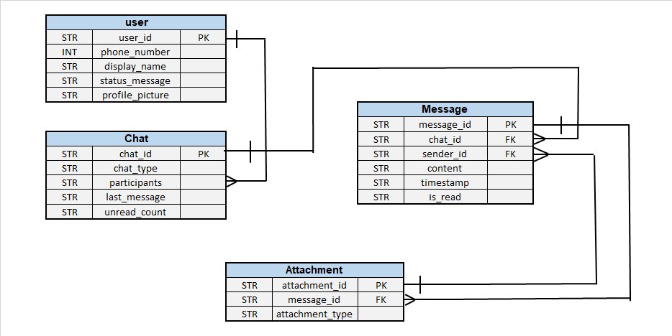

### **Conclusion**

In this case study, we delved into the design of whatsapp schema and Entity-Relationship diagram. whatsapp has revolutionized the way people share and engage with visual content, fostering connections and creative expression. The platform's intricate data model, consisting of entities like users, posts, comments, likes, shering, emoji, and associations, forms the foundation for its seamless functionality. By understanding this schema, we gain insight into how whatsapp effectively manages the complexities of user interactions and content sharing, contributing to its widespread popularity and continued growth in the world of social media.

**Github Link**

https://github.com/akshayinglecode/almabetterproject